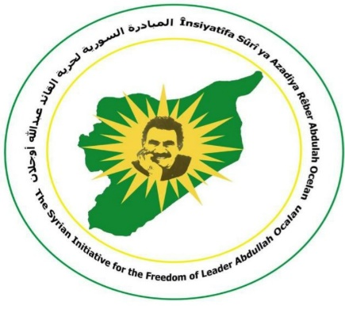 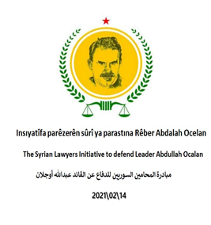

Syria, December 10, 2024

His excellency the Secretary General of the United Nations, Mr. António Guterres

Greetings of Truth and Justice:

At a time when we express our appreciation for the efforts of the United Nations organization in addressing human rights that are under attack; we Value greatly the theme of your High Commissioner for Human Rights, which is: "Our rights, Our future, right now." Because adopting such a cause was not made in vain, but rather based on the principle- that human rights are the path to solutions, since they play a decisive role and constitute a preventive, protective and transformative force as the common factor that binds us together to promote peace and stability.

Therefore, and because we are at the threshold of the seventy-sixth anniversary of the International Human Rights Day, which falls on the tenth of December of each year, we kindly bring to your attention the issue of the humanitarian Kurish leader Abdullah Ocalan, who has every right to be seen and heard of and not to be isolated, after all the international crimes he was subjected to, ranging from the terror expressed in kidnapping and then in a so-called trial by a non-independent, non-neutral party that put him in complete isolation; stripping and deprivation him of meeting with his relatives and lawyers and his defense team, in addition to successive disciplinary sanctions aiming at depriving him of his right to hope.

We believe that your excellency is aware of the leader Abdullah Ocalan circumstances. When he was kidnapped, he was exercising his right to political asylum in accordance with the Article 14 of the Universal Declaration of Human Rights- to escape persecution; yet he was deprived, with a terror level that is still at its highest levels, not only of this particular right, but of all the rights stated in the Universal Declaration of Human Rights; which are celebrated again on this day every year, starting with the right to life, freedom and security and concluding with the right to thought, conscience and freedom of expression; which in turn, prompts us once again to appeal to your excellency to intervene to achieve the physical freedom of the humanitarian leader Abdullah Ocalan, especially since there is a continuous global campaign that honors this goal- since its inception on October 10, 2023, and is still at its peak.

Sincerely,

Syrian Initiative for the freedom of the leader Abdullah Ocalan

Syrian Lawyers Initiative in defense of the leader Abdullah Ocalan

Mobail: +963934914629

Email: ocelan22019@gmail.com